**AO7 Assignment- Data Analysis**

**Homeless Shelter**

**Group L**

***Introduction:***

If we solve the issue of homeless people not having access to shelters, with our solution to create a user friendly and accessible shelter that can be used by campers and homeless people, then we will be able reduce the amount of prejudice that homeless people face. In addition to the solution of the shelter we will also be following a one-for-one business model.

***Task:***

Homeless citizens living in inclimate weather.

***Problem definition:***

Seeking an affordable and efficient shelter that can withstand different weather conditions.

***Pains:***

1. Shelter is not typically portable and is difficult to move from location to location
2. Homeless people do not have enough income to afford permanent and effective shelter
3. Homeless people often have to settle for sleeping under bridges or in areas that are not very safe without any shelter to protect them
4. Homeless people are more prone to getting sick from exposure to the elements

***Gains***:

1. Homeless people gain more of a sense of privacy and personal space
2. Homeless people have the warmth they need to protect them from the cold
3. The ability to have a portable shelter and extra storage to protect their belongings from the general public

***Assessing User Experience of Homeless People in Finding/Using Shelter:***

| - - | - | 0 | + | ++ |  |
| --- | --- | --- | --- | --- | --- |
| X |  |  |  |  | Privacy |
|  | X |  |  |  | Storage of personal belongings |
| X |  |  |  |  | Comfort |
|  | X |  |  |  | Access to food |
|  | X |  |  |  | Ease of transportation |
|  | X |  |  |  | Ability to access shelter |
| X |  |  |  |  | Protection from sickness |
|  | X |  |  |  | Sense of community |
| X |  |  |  |  | Safety |
|  | X |  |  |  | Access to medical resources |

The chart above assesses the pains and gains that are associated with being homeless. This will allow us to understand how to better produce a quality product, to continue to maintain the gains and try to fix the pains. This chart informs us which aspects of homelessness most negatively affect the quality of life of a homeless person and therefore which most urgently need to be addressed. From this, we learned that our product should focus primarily on these four aspects of homeless life: privacy, comfort, protection from sickness, and safety. Though there are many negative aspects of being homeless, this chart helps us hone in on which specific aspects our product should improve.

***Persona:***

Our user persona is a fictitious representation of someone who will use our product. Creating a persona helps us better identify the primary user base for our product and shapes our marketing strategies. To create our persona, our group discussed what population we felt our product was mainly geared towards. We then considered numerous characteristics of our user base such as age, marital status, lifestyle, and hobbies and created our user persona accordingly.

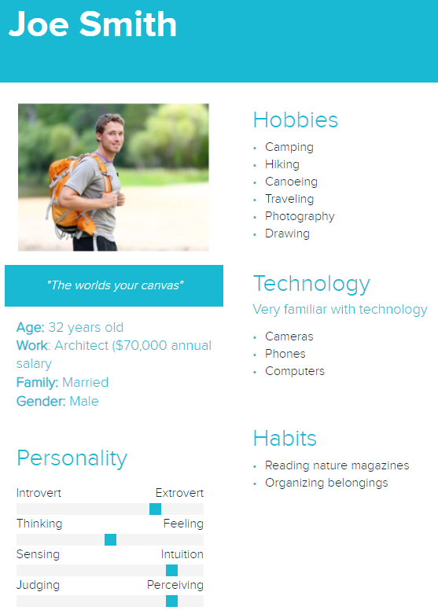

***User Needs:***

In order to best understand the needs of the potential users of our product, we created a chart outlining what we believed to be some of the most critical aspects of our design. Then, we rated each category by how important it was to include in our product given the needs of our users. Our team concluded that the most important features to include were long-term reusability, portability and convenience because our intended users will be using our product night after night, and have to carry it around during the day.

*1=least needed, 5=most needed

| User Need | Score (1-5) |
| --- | --- |
| Simple | 4 |
| Inexpensive | 3 |
| Portable | 5 |
| Long-term reusability | 5 |
| Comfortable | 3 |
| Convenient | 5 |
| Visually appealing | 3 |

Simple- The product needs to be simple enough to expand and compress quickly with ease and cannot be so complicated that it is difficult to understand and set up.

Inexpensive- Since we are planning on donating one shelter to a homeless person for every purchase, the product needs to be inexpensive enough to produce and sell while allowing for profit even with donating the shelters for free.

Portable- The product needs to compress enough to be portable and easy to carry around for people on the move.

Long-term reusability- The product needs to be of high enough quality to be reused and last long enough to shelter homeless people and campers for countless uses.

Comfortable- Though the product needs to compress and be portable, when expanded, the shelter provided needs to be comfortable to sleep and live in. In addition, the product must provide protection from the elements.

Convenient- The product needs to be easy to carry from place to place as well as set up and take down and must be able to be set up with any environment/location.

Visually Appealing- The product must be visually appealing enough to create a clean and beautiful city. While the product is first and foremost meant for shelter, it should also have an aesthetic element to it that beautifies cities and nature settings alike.

***Pairwise comparison Chart:***

The pairwise comparison chart helps us rank which features of our product we deem to be the most important. The chart also compares our initial rankings to our final rankings and weights them accordingly: the higher the total, the higher priority that aspect of our product is. For instance, we have decided that long-term reusability is the trait we value most in our product.

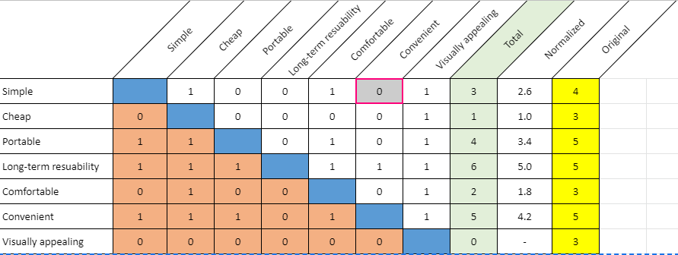

***Research Plan:***

1. **A description of the format of your primary research method (interview, focus groups, or survey)**
   1. For this project our group decided to use focus groups and interviews in addition to pre recorded interviews as our method of research. This was done to ensure that our group would get a large user base to gain information so that we can accurately judge the current market. This format also gives us the ability to gain accurate information on the market while making sure we don't trouble our user base.
      1. 2 Focus Groups (2-3 people)
      2. 4 interviews
      3. Youtube videos interviews with guided outlines
      4. Pre recorded of a homeless shelter interview
      5. Interviews from Invisible People (<https://invisiblepeople.tv/> )
      6. Survey→ (To Identify data for campers)
2. **A plan to find and reach out to an appropriate number of users (8-10 interviews, 2-3 focus groups, or 25-40 survey results).**
3. Our group decided to first reach out to friends and family that fit the market we are trying to capture. Our market is primarily young to middle aged adults, an age range that is old enough to buy a tent but young enough to go camping frequently. If this user base does not provide a sufficient amount of users for our research, we decided to create a marketing campaign to inform the public about our focus groups and encourage users to sign up. The primary way we would achieve this is by creating flyers and asking local businesses and corporations to discuss our product with their employees and customers and encourage them to sign up. Finally, if we still need more interviewees, then our group has decided to lean on virtual resources like Youtube videos and other pre-recorded interviews so that this way we have the ability to reach an even wider user base that is not only in our local area but other states and countries as well.
   * 1. Friends and Family
     2. Marketing (Zoom Meeting)--> Ventech, Leah friends and parents (need confirmation)
     3. Youtube videos (with guided outlines), Pre-recorded interview, Invisible people
4. **Procedures for making our process as ethical as possible**

To make this process as ethical as possible our team first decided to make sure that, regarding our focus groups, we will not be visually recording them or collecting the individuals’ names. This ensures that every person's right to privacy is respected. However, in order to also ensure that our group gets the data we need from our market, the interviewees will be asked if they are comfortable enough to have their voice recorded this way the group will be able to review the data at a later time to make sure that all the data is accounted for. If all the participants of the focus group are comfortable with being voice recorded the participants need to give verbal confirmation and the interviewers will also discuss the destruction of the data once all the data has been received. Throughout this process interviewees have the option to leave the study at any time and their identity will be kept private through the duration of this project. Another thing that our group hopes to do in order to make sure that ethical practices are being followed is that each interviewer will make sure that they **DON’T** engage in confirmation bias. This means that when a response is given from the interviewee and it is not an answer we expected to get the group will write down and record only what the interviewee said and will **not change anything** from their response.

1. **Plan to Identify Additional Research:**

Because the goal of our design is to satisfy the needs of two different audiences, we need to make sure that our final product achieves the full capacity of its purpose. In order to do this, we need a thorough understanding of the needs of both campers and homeless people. Since the majority of our interviews will be with campers, we will need to do our own research about what the needs are of those who live on the streets. To do this, we will look for data about the circumstances of the homeless population, including any common medical issues that might make living on the streets especially difficult. We want to create our design with compassion in mind, so understanding these circumstances is a cornerstone to our project. In addition, we will explore several websites for homeless shelters to find testimonials from shelter staff or from shelter residents to gain further insight into a homeless person’s life.

We will also need to do research regarding the materials we will eventually use for prototyping and for assembling our final product. We want to optimize the quality of materials for their durability, providence of warmth, and aesthetic, while also ensuring that our product will turn out to be an appropriate price for the market.

Finally, if we decide to take this project past the design stage, we will want to do research on companies that could manufacture any parts for us that we are unable to create given our own facilities. To afford this, we would need to research and apply for grants that would help us to launch our product into the market.

The eight sources of outside research, condensed, are:

1. Data/statistics on homeless from government websites
2. Data/statistics on homeless from non-profit websites
3. Personal testimonials of homeless from non-profit websites
4. Data on trends for camping products on the market
5. Statistics on current tent competitors (which products are doing well right now?)
6. Information on different types of tent materials’ cost, durability, etc.
7. Research on potential part manufacturers
8. Research on eligibility for different types of grants
9. **The role of each team member**
10. We have decided that, while conducting research, the team will be split into two partner pairs. Each pair will be tasked with completing one focus group and two interviews. The partners will discuss and decide amongst themselves how they will split up the work and responsibilities for each task. For each task, the interview questions must be asked and notes taken on the responses. Someone will also be in charge of voice recording each meeting, but only after the users have consented to being recorded.
    1. 2 Focus Groups, each pair is responsible for 1

**6) Possible Interview Questions**

1. How often do you go camping?
2. What do you find to be the most difficult part of camping?
3. Do you prefer to camp alone or with others?
4. What type of weather do you typically camp in?
5. If you camp during cold weather, how do you typically stay warm at night?
6. On average, how many things does each individual person carry with them when camping? How many packs do these items require?
7. How would you describe your comfort level when sleeping in the shelter you currently use? What changes to that product would you make that would improve your camping experience?
8. Do you have any camping gear brands that you are loyal to? What do you like about those brands?
9. Do you typically prioritize quality or price when it comes to camping gear?
10. Having you noticed any recent trends in the camping industry?
11. How much would you be willing to pay for a product like this?
12. Do any other products/services come to mind when you think of this product?
13. What is your day job and what character traits do you think one must have to perform this job well?
14. What are the day-to-day tasks of your job?
15. How do you incorporate camping into your life? Do you see camping as an individual activity or a family-oriented activity?
16. If you knew that buying a certain camping product would contribute to providing shelter for the homeless, would you be more inclined to purchase that product?
17. Do you have any memorable experiences with the homeless population or serving in homeless shelters?

***Market Characteristics:***

1. **Stakeholders:**

Stakeholders are a person or group of people that are affected due to a common interest especially in business. As a result the people or group of people selected below are all affected in some way with the development of a homeless shelter.

* 1. Homeless people
  2. Campers (young/old people)
  3. Homeless Shelters
  4. People living in an area with a high homeless population
  5. The business around homeless people
  6. Other camping business (competitors)
  7. Camping grounds (nature reserves)
  8. City/Community leaders (mayors, governors)
  9. Producers and suppliers
  10. Distribution companies
  11. Shareholders (grant donors)

1. **Market Size:**

Defining the market size will give us an estimate of how many people are in our market and thus how many potential users/buyers there are locally, nationally, and globally.

* 1. Campers Market Size:
     1. When examining the camping tent market from the years 2020 to 2025 in the region of North America, Europe, Latin America, the Middle East, and Africa, it was identified that the current market revenue is valued approximately 3 billion dollars in 2025. That being said when factoring the **CAGR (Compound Annual Growth Rate) of 6%** and the **average price of a tent being $80** it can be identified that the population density of campers can be represented below with the graph. ([Camping Tent Market Size & Share | Global Industry Analysis Report, 2020-2025 (arizton.com)](https://www.arizton.com/market-reports/global-camping-tent-market-2025))

| Year | Market Size (Revenue) | The **left side** of the table includes the year and the market size in a monetary sense. While the **table on the right** includes the year and the Market size in terms of population which was achieved by taking the average price of one tent which was $80 and then dividing it by the market size (Revenue) to get the price of one tent which we assumed to be equivalent to one buyer of a tent or in other words a camper. | Year | Market Size (People) |
| --- | --- | --- | --- | --- |
| 2020 | 2,201,712,067 | 2020 | 27,521,401 |
| 2021 | 2,342,246,880 | 2021 | 29,278,086 |
| 2022 | 2,491,752,000 | 2022 | 31,146,900 |
| 2023 | 2,650,800,000 | 2023 | 33,135,000 |
| 2024 | 2,820,000,000 | 2024 | 35,250,000 |
| 2025 | 3,000,000,000 | 2025 | 37,500,000 |

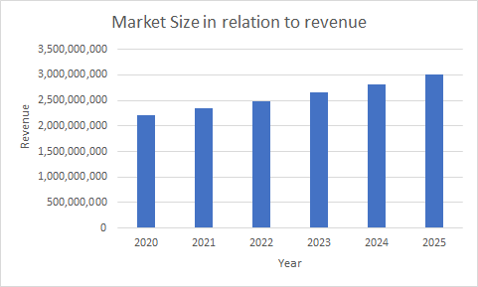

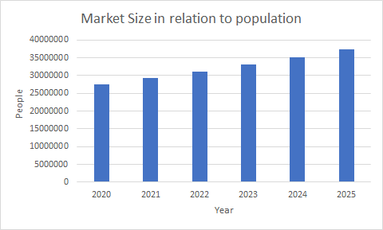

* 1. Homeless:
     1. In **2019, there were approximately 570,000 people** experiencing homelessness in the United States. This number is predicted to rise due to COVID-19 and will continue to rise as the economy and employment rates suffer and begin to recover. (<https://www.statista.com/statistics/555795/estimated-number-of-homeless-people-in-the-us/>)

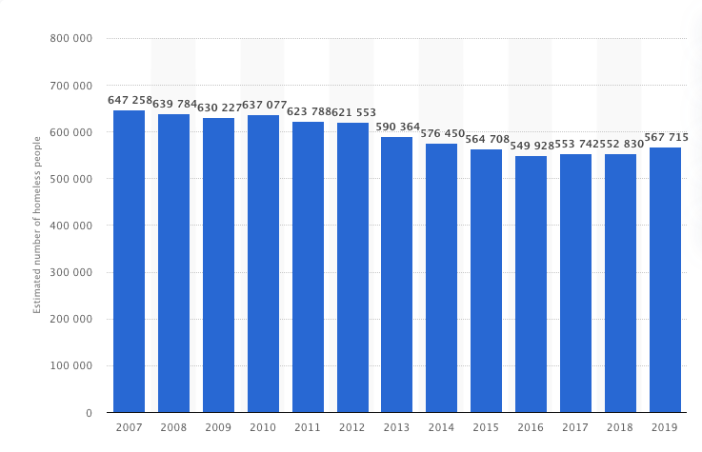

1. **Current Alternatives:**

Understanding current alternatives to our product that are already on the market is imperative to ensuring that our product satisfies our users’ needs to the best of its ability. By assessing alternatives in each category of user needs, we are able to better understand which user needs are overlooked and not accounted for, allowing us to make our product stand out among competitors in the market. From this high-level comparison matrix, our group learned that the majority of alternatives do not meet user needs when it comes to long-term reusability, comfort, and visual appeal.

| **User Need** | **\* Tents** | **\*\*\* Cabin** | **\*\* Blanket** | **\*\* Homeless Shelter** | **\*\* Under bridge** | **\*\* Nothing** |
| --- | --- | --- | --- | --- | --- | --- |
| **Simple** | **X** | **X** | **★** | **X** | **★** | **★** |
| **Inexpensive** | **X** | **X** | **★** | **★** | **★** | **★** |
| **Portable** | **★** | **X** | **★** | **X** | **★** | **★** |
| **Long-term reusability** | **★** | **★** | **X** | **X** | **X** | **X** |
| **Comfortable** | **★** | **★** | **X** | **★** | **X** | **X** |
| **Convenient** | **★** | **X** | **★** | **X** | **★** | **★** |
| **Visually Appealing** | **★** | **★** | **X** | **★** | **X** | **X** |

**Key:** * for both homeless and campers, ** for homeless, *** for campers

***Data Analysis:***

1. ***Secondary Research***
   1. **Source 1: Policy Advice**

*(This source was used in order to obtain data on homeless people (User Base) from reliable sources like the government)*

* Permanent housigintervantions have grown by 450% in 5 years
* The number of homeless in the US is estimated at 552,830
* Every year, 13,000 homeless people in the US die
* Homeless people have an average life expectancy of 50 years
* 20% of homeless individuals are kids
* Only 3% of affordable housing is available to people with extremely low income
* 70% of homeless people can receive temporary beds
* Over 65% of the homeless population in the US is in homeless shelters
  1. **Source 2: My Ope Country**

*(This Source was used in order to obtain data on our competitors, this data allowed us to see which companies currently dominate this space and how we can come in and separate ourselves from the rest of these people)*

* Top picks for tent brands are MSR, Big Agnes, Coleman, Kodiak Canvas, Jelty, R.E.I., The North Face
* Aluminum tent poles are stronger than carbon composite or fiberglass poles but are often more expensive and heavy. Rip-stop nylon fabric is cheap and will keep campers safe, warm, and dry and can endure shoes and harsh winds and rain.
* Material reinforcement on stress points and material that is at least four layers thick will be stronger against tears
* Removable rain flys with a mesh vents allows fresh air to enter the tent
* Roof-only styles are most susceptible to rain and moisture
* MSR: MSR products are made to last and withstand harsh environments and sell a variety of tents. MSR is known for withstanding freezing temperatures and summer. Quite expensive but good for backpacking and lightweight.
* Kodiak Canvas: hydra-shield canvas makes tents unique by providing breathability and air flow. Tents are not easily susceptible to rommon rips and tear and are made to last a lifetime.
* Coleman: known for rain flies that come with nearly every one of their tents. Tent line features a diverse price range for every customer budget. Known for making large family tents.
* Big Agnes: Tents are easily constructed for quick assembly. Many different styles to fit every individual need and provide an affordable price point.
* Kelty: credited with creating the first aluminum backpack. Seep backpacking and camping in mind. Fly vents keep out even the smallest gants.
* REI: donate millions of dollars each year to the environment, positive cause and durable gear. Known for making great tents at an affordable price.
* The North Face tents are great for cold weather. Designed for 1-4 people. Small but can withstand crazy temperatures while still having a good design.
  1. **Source 3: Big4 Holiday Parks**

*(This source was used in order to identify the most useful and durable material that can be used from our tents, because something that we valued high on our User needs chart was making our product have a long-term reusability factor)*

* Cotton/Canvas: extra temperature regulation, keeps you cozy but has great ventilation when things get too warm, less prone to condensation. Customers have to “weather” the tent themself before taking it camping to prevent moisture from getting in. Cotton/canvas is one of the more durable and waterproof tent materials available.
* PVC-coated tents: polyvinyl chloride coating makes canvas tents waterproof but also makes tents more prone to condensation so it’s essential to have good ventilation.
* Polyester-cotton: Provide strength and durability. Does not have to be coated to be waterproof but most have an additional waterproof layer. More affordable compared to other tent fabrics and will last many years.
* Polyester: More durable than nylon and available in a variety of coatings. The type of coating will affect the price. Tents need a coating with enough ventilation but does not let moisture in. Does not shrink or get heavier after coming into contact with water. Less affected by sunlight so good for summer.
* Nylon: Light material that ensures weight will stay to an absolute minimum. Among the most affordable tents on the market. Nylon fibres do not absorb water so an additional coating is not necessary, which also makes it lighter when wet. Some companies add a silicone, polyurethane, or acrylic coating. A coating should focus on durability. Silicone coating offers best overall protection but acrylic coatings are better for cost. Use ripstop weave in fabric to make it extra strong and durable.
  1. **Source 4: National Parks Service**

*(This source helped identify how many campers were camping under the national parks service. This was done in order to generalize the population of the data, it was decided that identifying all these campers will be a big enough sample size to obtain accurate data off of.)*

* In 2019 the amount of recreation visits happening within the National Parks Service was 327,516,619 people.
* In 2019 out of the 327,516,619 people visiting the national parks 13,860,047 stayed overnight within the national parks and this includes both recreational and non-recreational.
* In 2019 3 parks had more than 10 million recreation visits. These parks were Golden Gate National Recreation Area, Blue Ridge Parkway, and Great Smoky Mountains National Park.
* In 2019 11 parks had more than five million recreation visits, 80 parks had more than one million recreation visits, and finally 25 national parks had more than 1 million recreation visits.
* In 2019 the top 5 most visited parks were Golden Gate National Recreation Area which was at 15 million people, next was Blue Ridge Parkway at 14.9 million people, Great Smoky mountains National Park at 12.5 million people, Gateway National Recreation Area at 9.4 million people, and then finally Lincoln Memorial at 7.8 million.
* Over the last 5 years the total recreational visits for all national parks was 327,516,619 people in 2019, 318,211,833 in 2018, 330,882,751 in 2017, 330,971,689 in 2016, 307,247,252 in 2015 and finally in 2014 it was 292,800,082 people.
  1. **Source 5: Information About Being A Certified B Corporation**

*(This source was used in order to identify the direction of the project and where it should be going towards the end)*

* Certified B corporations envision a global economy that uses business as a force for good, and is a corporation that is purpose-driven and creates benefit for all stakeholders, not just shareholders.
* B Corporations Certification doesn’t just evalue a product or service; it assesses the overall positive impact of the company that stands behind it.
* B corps set the gold standard for good business and inspire a race to the top creating performance standards and legal structures being used by thousands of other businesses around the world.
* Any for profit company with at least a year of operations may pursue B corp certification. There is no minimum or maximum size, certain companies such as those under a year old, those with related entities, or large multinational and public companies, have additional consideration and requirements.
* B corp Certification is based in part on a companets verified performance on the B Impact Assessment which asks questions about a company’s fiscal year. This means that companies with less than one year of operation are not yet eligible for B corp Certification. Instead, they may pursue Pending B Corp Status, designed to set a startup on the right path to full certification.
* Certifying as a B Corporation goes beyond product or service level certification. B Corp Certification is the only certification that measures a company's entire social and environmental performance.
* Positive impact is supported by transparency and accountability requirements. B Corp Certification doesn't just prove where your company excels, it now commits you to consider stakeholder impact for the long term by building it into your company’s legal structure.
  1. **Source 6: Interesting Engineering**

*(This source was used in order to gather data on new technology in the camping sector and in order to identify the current market we are working with)*

* Shift in sales from traditional equipment like pole tents and rope to modern equipment like backpacking tents, accessories, stoves, and coolers
* Three big trends: camping equipment design, eco-friendly equipment, camping programs
* Equipment design: high-tech equipment to camp and stay connected such as ultra-compatible equipment, stoves that charge your phone, water-repellent sleeping bags, and bear-proof coolers. The biggest tech trend is hydrophobic materials that repel water and can be applied to everything like sleeping bags and other textile gear.
* Eco-friendly equipment: Manufacturers are starting to introduce “green” tents that are made from recycled materials treated with waterproof coatings that are free from harmful chemicals.Green materials generally cost more to manufacture so green products are sold at a premium and you may be able to charge 50% more for the end result.
* Camping programs: new wave of camping service providers that offer campsites as well as excursion and adventures under the guidance of professionals.
  1. **Source 7: Invisible People**

*(This source was chosen to get a better idea on what kind of people are homeless in America and how they live)*

Homelessness in America:

* Reasons: People become homeless for various reasons including economics, laws and public policy decisions, wars, natural disasters, societal trends, and public attitudes about who deserves support, not just not having enough wage to cover living expenses.
* Types of people homeless: Men and women, Families with children, Unaccompanied youth, Seniors, Veterans, Black and Native Americans.
* In more recent times, the number of homeless people has increased despite federal and other efforts to end homelessness for specific groups of people. Some people experience homelessness throughout their whole lives.
* Where they stay: Homeless people stay in emergency shelters, domestic violence shelters, and motels. They also live temporarily with friends and family and in cars, tent encampments, parks, campgrounds, and woods as well as under bridges and on streets and sidewalks.
* Physical and mental stress: Many homeless people have experienced domestic violence and other traumas. Homelessness also leads to increased feelings of uncertainty, vulnerability, and isolation. Many homeless people do not have access to medicine, regular physical or mental health care treatment, and education and job training opportunities.
* Possibility to help homeless people: Despite all this, it is possible to end homelessness. There are proven programs and policy solutions that support people in rebuilding their lives.
  1. **Source 8: United Way of the National Capital Area**

*(This source was used to identify the effect that covid-19 had on the homeless population)*

* Social services have become more limited throughout 2020
* Federal order to temporarily halt evictions to prevent the spread of COVID-19 which created a financial burden for landlord by housing renters with no payment
* In some states, households had to spend more than 50% of thor household income on housing payments (California, New York, Hawaii)
* Availability of health care has helped reduce spread of COVID-19 in homeless population with a prevalence of 9% on average
* From June to October, the COVID positivity rate for those experiencing homelessness wason average between 9% and 12%.
* COVID-19 has exacerbated many pre existing issues for those that are homeless
* Evictions due to COVID-19 left many people experiencing homelessneess and shelter were also forced to reduce occupancy at the same time

1. ***Primary Research:***

The Primary Research section includes recorded videos of real homeless people. These videos were watched by one member on the team and guided notes were taken through the duration of the video which can be found in the appendix. This was done in order to accurately understand our homeless population market like their wants and needs in a product, this was done so that during the design process we can accurately customize the product to fit their needs and wants.

**Invisible T.V. Interviews**

* 1. **Rita (Invisible people interview)**
     1. Rita was interviewed for the first time about six months prior to this most recent interview. The interviewer stayed in touch with Rita after their initial contact and decided to interview Rita again to see how the pandemic has changed her life as a homeless person. This interview was only conducted after Rita consented to being recorded on video. This interview was conducted in a manner closer to a casual conversation rather than an interrogation. The interviewer did not ask many specific questions but rather allowed Rita to talk about the things she felt were most important in her life right now. One specific question that was asked was “if you had three wishes, what would they be?” This question was asked to provide insight into what aspects of homeless life are most difficult for Rita and what she would change about her life or the society she lives in. After talking to Rita, our group is able to better understand the struggles she faced as a homeless woman in LA and what parts of being homeless frustrated her the most. One aspect of homeless life that frustrates Rita are programs that claim to care about the homeless community but provide quote on quote “support,” sometimes in the forms of lunches, only once and do not continue to help. Rita cares deeply about the environment and is even involved in a railroad beautification project called the Rainbow Forest Project. Rita also trims the palm tree and bushes near the railroad tracks to make it safer for homeless people living there. She also is highly involved in the community and even ran for neighborhood council to raise awareness about life as a homeless person and to support programs that support the homeless community. Rita is most frustrated by the lack of support for housing projects in LA and the interference of police in her life like the tickets and ambiguous instructions/threats from law enforcement to move during the lockdown. After interviewing Rita, the biggest takeaways are these: the wind, cold, and rats are the most harmful environmental conditions she experiences as a homeless person, personal hygiene is very difficult to maintain, homeless women are continuously abused and mistreated and are in need of safe refuge, and the general public should support affordable housing programs rather than the luxury housing projects typically found in LA. Rita’s three wishes are that she wished she had a pet unicorn, that she was not homeless, and that no one ever has to experience homeless ever again.
  2. **Simba (Invisible people interview)**
     1. Simba is a 65 year old homeless man who, after his wife died of diabetes complications four years ago, became severely depressed and started self medicating marijuana to help him sleep better. He was evicted from his home for smoking and has been homeless ever since. Simba was interviewed after he consented to being video recorded and asked questions. He also gave his street name in order to better protect his identity. Simba and the interviewer first met when a mutual friend was handing out cupcakes to the homeless people in the area. After meeting for the first time, the interviewer came back and interviewed him about his experiences as a homeless senior in Venice, LA. Simba was asked questions like “what was your first morning as a homeless person like,” “how are you surviving out here on the streets,” “what would you want people who judge you to know about homelessness,” and “if you could grant three wishes, what would they be?” Though these questions provided somes structure to the interview, the interviewer mainly just let Simba talk and tell his own story rather than asking him many specific questions. Simba expressed that the main way he survives on the streets is by dumpster diving, or “living off the land” as he calls it, reusing resources that people throw out every day. The biggest thing that has impacted Simba’s life as a homeless man are the motherly figures who watch over and care for the people in his community. He expressed his admiration and gratitude repeatedly for the people that watch over them and protect them when no one else will. For Simba, one of the most difficult things about being homeless are the health issues. As a senior, Simba struggles with incontinence and finds it extremely difficult to maintain his personal hygiene and privacy. Simba also describes how many homeless people do not even know the date or time of day. In addition to these struggles, Simba describes the most frustrating aspects of being homeless to be the lack of structure in his life, and being mistreated and judged by policemen and everyday people. Throughout the interview, cars were continuously driving past the spot where Simba lives, the noise being too loud to hear him talk as some onts in the interview. Simba's three wishes would be that everyone around the world appreciates their mothers, to not be seen as a target and mistreated by society, and that everyone becomes more thankful and works to spread love and not evil.
  3. **Mercy (Invisible people interview)**
     1. This interview was conducted in a manner closer to a casual conversation rather than an interrogation and not many questions were asked. Mercy had been homeless for 3 years on the streets of Los Angeles. When asked what happened to make him homeless, Mercy said “what didn’t, a little bit of that. A little bit of this.” Mercy kept mentioning how he used to judge homeless people before he himself became homeless and went on to talk about how a lot of homeless people are just ordinary citizens and that they became homeless because “stuff happens''. Mercy made safety seem like a major issue among the homeless. He explained to the interviewer how he got shot in his tent a year and a half before the interview. He also talked about how some homeless lady had her tent beams stolen and how he had to help her by giving her an extra tent. When asked what he likes to do, Mercy said he was a good cook and can cook anything. He would feed the homeless people on his street and cook for them. Mercy is very sympathetic towards other homeless people and says they are a community. When asked about what his 3 wishes would be, one wish he had was enough money so that he can at least get himself some basic necessities and live a life but also enough so that he could give back to other homeless people. When asked about future plans he replied with “I’m gonna get out of here” and said most homeless people have future plans on how to get out but struggle with their basic necessities. According to Mercy, “The streets have their own language. A person has to either adapt to the lifestyle or get killed. If you weren’t hard before South LA, the streets make you that way.“
  4. **Open Shelter Interview Summary**
     1. In the “Open Shelter” interview, there were two homeless interviewees who shared about their experiences being homeless. As explained by one of the interviewees, he fell into homelessness due to his lazy habits. He said that he didn’t care enough about managing his finances and that he used drugs. There was a period of cold days where he had to take refuge in a church, and he said he didn’t know how people who stayed outside those days made it. He said that he is currently trying to get back on his feet. He put a lot of emphasis on how he wishes there were more programs out there to help people like himself get education and jobs. He also said he wishes there were more places where he could wash his clothes, take showers, and get medical help. When it comes to shelter, he explained that he didn’t like how tents made him feel confined, so he usually chooses to sleep in a sleeping bag instead. He said that it was important to him that he had somewhere that he could stay warm and dry. Sometimes bugs were an issue for him, but racoons often attacked his tent and would steal food from him. He also had to worry about other people stealing his belongings. After explaining that, he said that the biggest concern was safety. He said that a lot of people have sleeping bags that keep them warm enough, but that the safety features could be greatly improved. A few other things he mentioned included how he kept personal identification papers in a ziplock bag in his backpack, how he sometimes used a grocery cart to transport his belongings, and how a good solution for a shelter would also mean that it is suitable to be carried with you on a city bus (in other words, nothing that is too big and bulky to be taken on the bus). After watching this video, we are taking the notion of safety, protection of belongings, and sanitation very seriously and we will be looking for ways to integrate these ideas into our current design to make it more user-friendly for homeless people and campers.
  5. Focus Group with Bob (Alias) and Charlie (Alias)
  6. hri*insert summary here*

***Works Cited***

*A material world. How to choose the best tent fabric for you | BIG4*. (2020). BIG4 Holiday Parks. <https://www.big4.com.au/tips-and-inspiration/tips-advice/camping/how-to-choose-the-best-tent-fabric#:%7E:text=Tents%20made%20completely%20from%20polyester,a%20specific%20polyester%20tent%2C%20though>.

A.A.&. Intelligence. (2020, February). *Camping Tent Market Size & Share | Global Industry Analysis Report, 2020-2025*. Arizton Advisory & Intelligence. <https://www.arizton.com/market-reports/global-camping-tent-market-2025>

Adavelli, M. (2021, January 31). *Homelessness statistics in the US for 2020 | Policy Advice*. PolicyAdvice. <https://policyadvice.net/insurance/insights/homelessness-statistics/#:%7E:text=On%20a%20single%20night%2C%20more,are%20living%20on%20the%20streets>

Certified B Corporation. (n.d.). *Certified B Corporation*. Retrieved February 4, 2021, from <https://bcorporation.net>

Conghalie, B. (2020, October 31). *Best Tent Brands (and Shelters) of 2021*. My Open Country. <https://www.myopencountry.com/best-tent-brands-shelters/>

Emmiemartin. (2018, August 09). 77 million Americans Go Camping-and 22 percent spent nothing to get started. Retrieved February 06, 2021, from <https://www.cnbc.com/2018/08/09/how-much-first-time-campers-pay.html>

English, T. (2019, October 4). *Hottest Trends in Camping: How Has Technology Changed the Industry?* Interesting Engineering. <https://interestingengineering.com/hottest-trends-in-camping-how-has-technology-changed-the-industry>

Fish, G. (2021, January 11). *The Impact of the COVID-19 Pandemic on Homelessness in the United States*. United Way NCA. <https://unitedwaynca.org/stories/effect-pandemic-homeless-us/>

Moses, J. (2020, May 22). *COVID-19 and the State of Homelessness*. National Alliance to End Homelessness. <https://endhomelessness.org/covid-19-and-the-state-of-homelessness/>

Homelessness Archives. Invisible People. Retrieved February 4, 2021, from <https://invisiblepeople.tv/category/learn-more/homelessness/>

Horvath, M. (2020, Dec. 2). Evicted After Wife Died, Now Homeless in Venice Beach. *Invisible People.* [https://invisiblepeople.tv/videos/elderly-homeless-man-venice- beach/](https://invisiblepeople.tv/videos/elderly-homeless-man-venice-)

Horvath, M. (2020, Dec. 30). UPDATE: Rita is still homeless in Chatsworth. *Invisible People*. [https://invisiblepeople.tv/videos/homeless-woman-chatsworth-los-ang eles/](https://invisiblepeople.tv/videos/homeless-woman-chatsworth-los-ang)

Horvath, M. (2021, Jan. 20). Homeless on the Cruel Streets of South Los Angeles. *Invisible People.* <https://invisiblepeople.tv/videos/homeless-south-los-angeles/>

Statista & US Department of Housing and Urban Development. (2007–2019, January 20). *Estimated number of homeless people in the U.S. 2007-2019* [Dataset]. US Department of Housing and Urban Development. <https://www.statista.com/statistics/555795/estimated-number-of-homeless-people-in-the-us/>

Jayakumar, A. (2021, Feb. 4). Open Shelter.

*Visitation Numbers (U.S. National Park Service)*. (2020, March 10). National Parks Service. <https://www.nps.gov/aboutus/visitation-numbers.htm>

***Appendix:***

| **AO7 Assignment** | | | |
| --- | --- | --- | --- |
| **Project Manager for Assignment** | | | |
| Ella Wulforst | | | |
| **Deputy Manager for Assignment** | | | |
| Avi Popat | | | |
| **Drafted Assignment** | **Reviewed Assignment** | **Revised Assignment** | **Proofread Assignment** |
| Ella Wulforst | Ashwin Rajkumar | Avi Popat | Leah Norton |
| **Created Figures** | | **Created Tables** | |
| Avi Popat | | Ashwin Rajkumar | |
| **Other Contributions** | | | |
| N/A | | | |
| **Problems Overcome** | | | |
| N/A | | | |

***Guided Notes from video Data***

***Open Shelter Data Ashwin:***

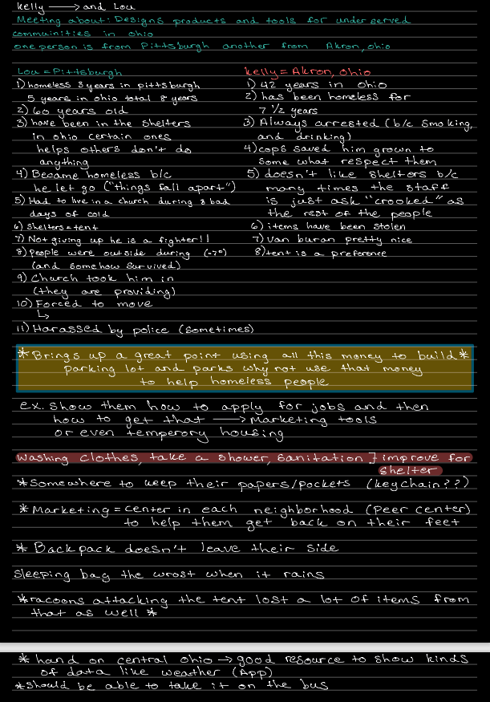

***Open Shelter Data Leah:***

Became homeless from laziness, drug use, poorly managed finances

Took shelter in a church

Trying to get back on feet

Don’t like tents because don’t like being confined, usually just sleep in sleeping bag

They need help with getting jobs, education

They need places to wash their clothes, take showers, get medical help

Children in need of food, clothing, medical supplies

Keep documents in backpack in a ziplock bag

Use Kroger carts to transport some belongings

Some have a lot of belongings, others just keep the things they really need

Need somewhere to keep dry

Weather resistant sleeping bags are the best kind of sleeping bags

Satisfied when you’re kept dry and warm

Sometimes bugs can be a problem but they aren’t the most pressing issue

Raccoons attack their tents and steal food from them

Have to worry about other people coming up and stealing your things

It would be good for the solution to be suitable for taking with you on the bus

The biggest concern is keeping stuff safe

A lot of people have warm sleeping bags, so the shelter doesn’t necessarily need to be super warm, focus slightly more on safety features

***Mercy Invisible TV interview Data Avi:***

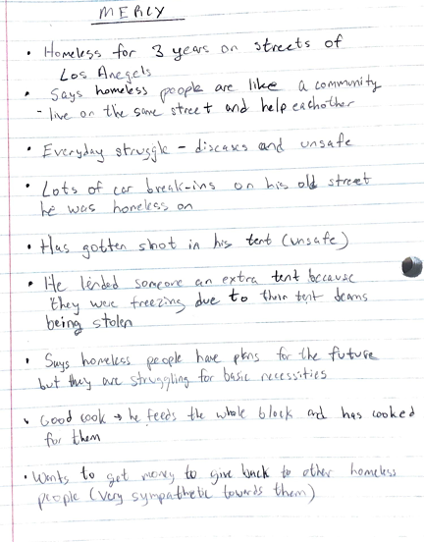

***Rita Invisible TV interview data Ella:***

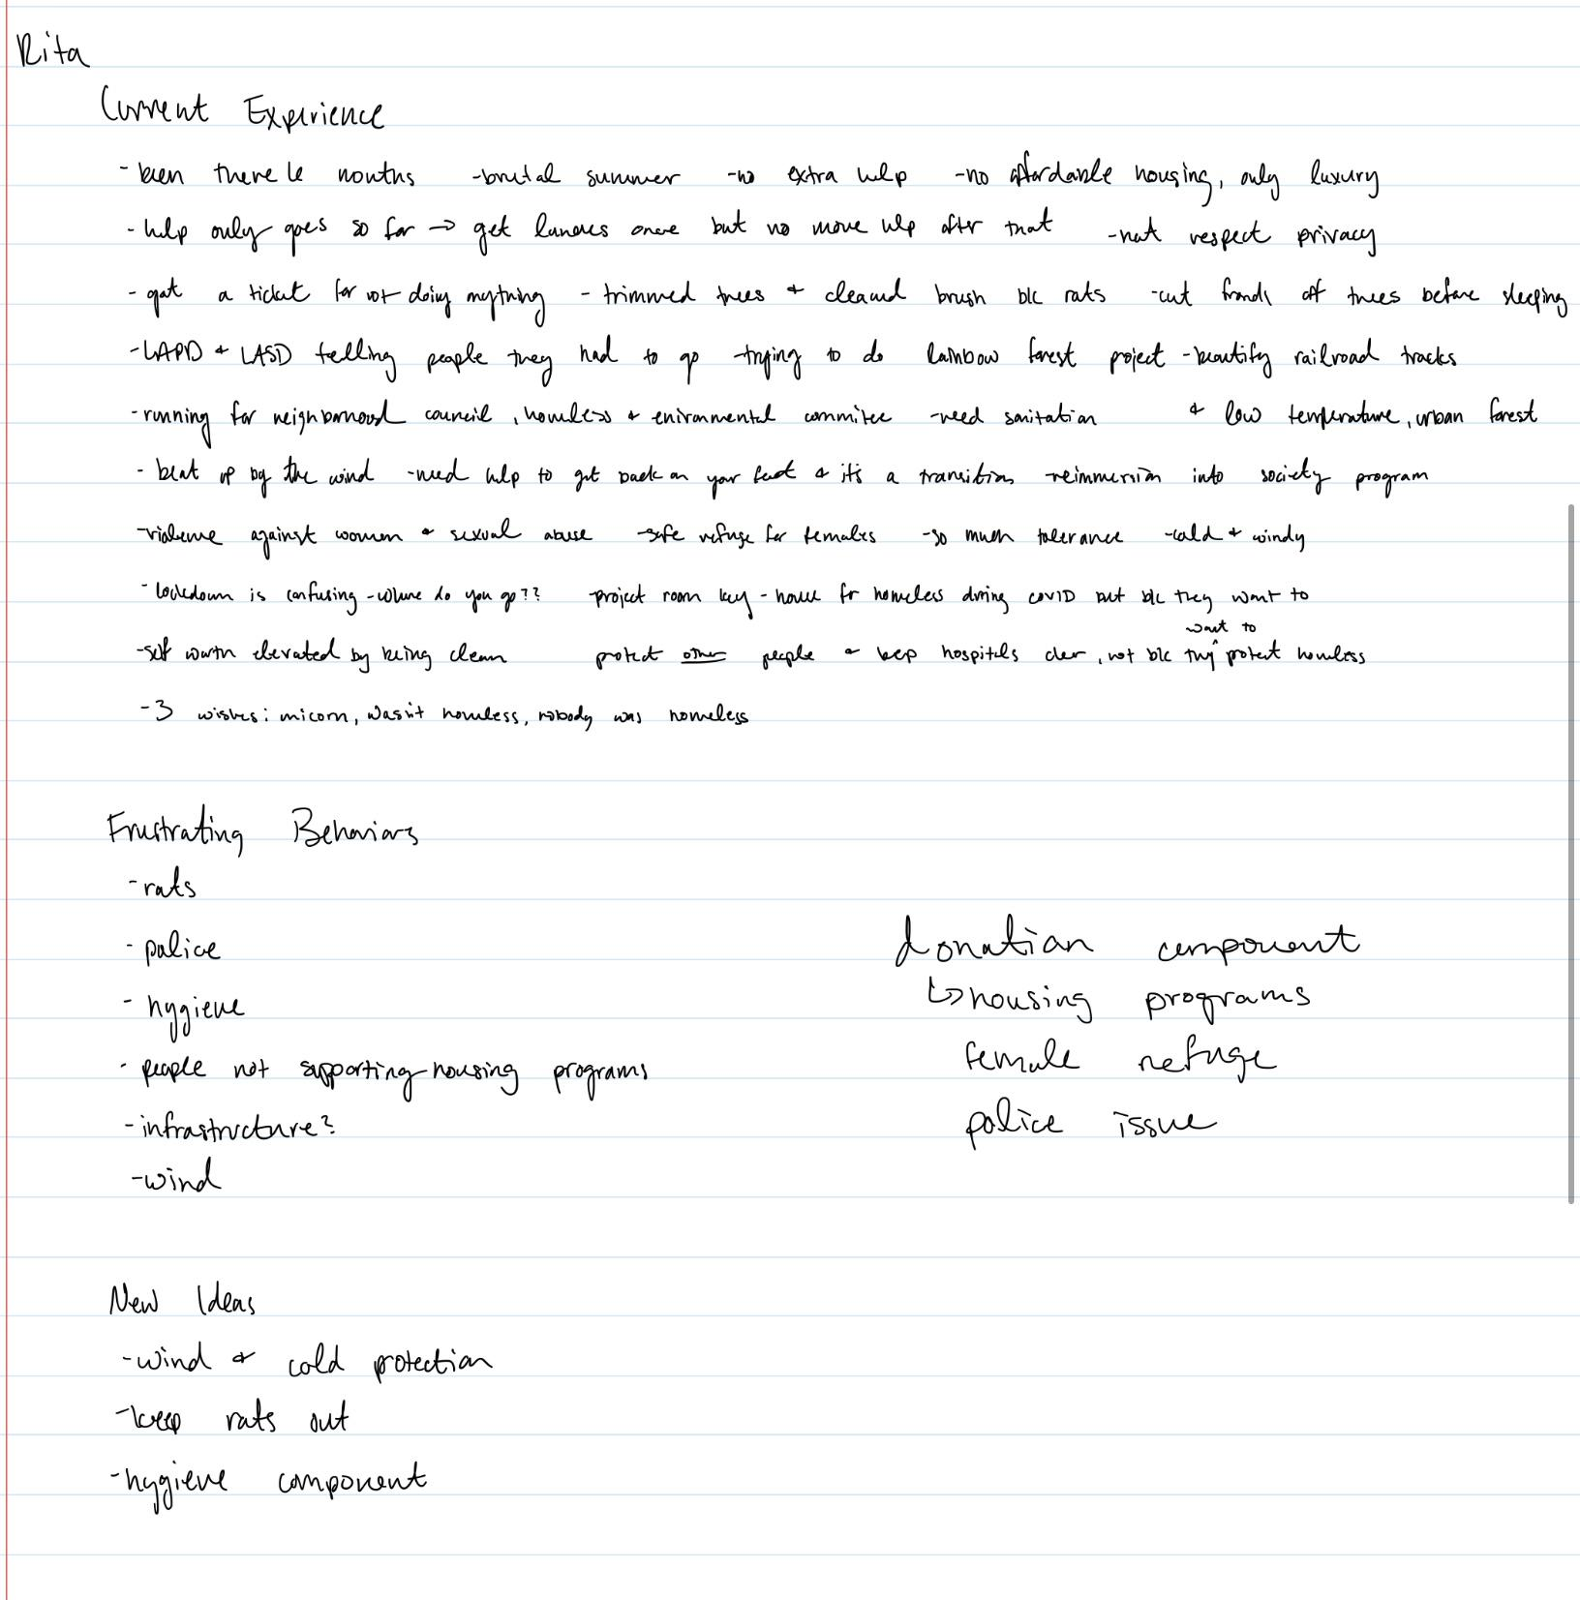

***Simba Invisible TV Interview Ella***:

